Chloe Lincoln

Cloud Computing

06-17-2019

**Assignment 1**

**Github:** <https://github.com/clincol2/CCAssignment1>

**Explanation and Analysis:**

**Part 1:**

I only made two changes to the original code (Example # 4).

**I changed line:**

Vm vm2 = **new** Vm(vmid, brokerId, mips, pesNumber, ram, bw, size, vmm, **new** CloudletSchedulerTimeShared());

To:

Vm vm2 = **new** Vm(vmid, brokerId, mips * 2, pesNumber, ram, bw, size, vmm, **new** CloudletSchedulerTimeShared());

**And I added:**

//create another machine in the Data center

List<Pe> peList2 = **new** ArrayList<Pe>();

peList2.add(**new** Pe(0, **new** PeProvisionerSimple(mips)));

hostId++;

hostList.add(

**new** Host(

hostId,

**new** RamProvisionerSimple(ram),

**new** BwProvisionerSimple(bw),

storage,

peList2,

**new** VmSchedulerTimeShared(peList2)

)

); // This is our second machine

The main difference I saw was the Data Center ID had changed. Also, both Finish Times were the same originally, but in the modified code, one was half the time as the other. (This can be seen in Assignment 1 Part 1 Screenshot). I am not sure why runtime was affected for one of the Cloudlets. Originally both took 160 , while modified, one was 80 and the other was still 160.

**Comparison:**

**Original:**

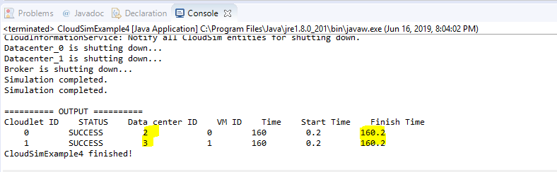

**Modified Code:**

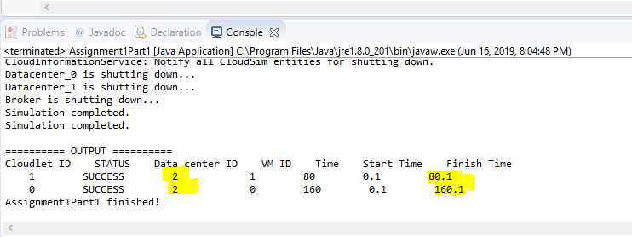

Also, the order of the Cloudlet ID switched spots (can see above).

**Part 2:**

For Assignment 1 Part 2, several Virtual Machines (VM) failed when it tries to allocate to RAM, MIPS and BW.

While I am not sure why the VM failed and several had to be deleted (VM # 0-11; same as original), here is a list of reasons why I think it may have failed.

1. Insufficient permissions
2. Unsupported OS versions
3. File-size issues (Most likely this one, since we increased the size of the scope)
4. The host can't handle the backup load (Second most likely, for same reason as above)

Regarding run time, it made sense that it took almost twice as long as the original since we doubled the Virtual Machine count and the Coudlet count.